Regular Expressions

Sequence of characters used for pattern matching

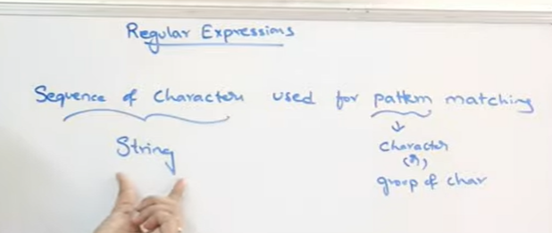

Regex module

Re package

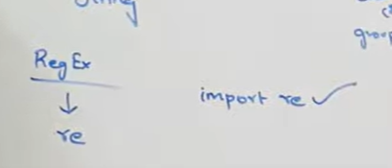

Basic functions or methods available

1. Findall: it will return list of all matches
2. Search – it will return match object
3. 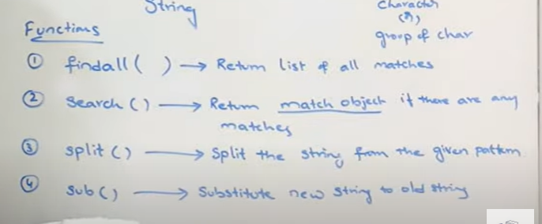
4. 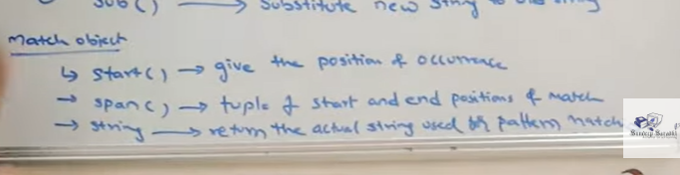

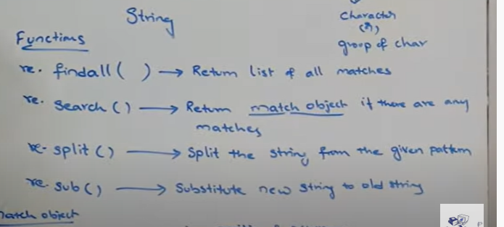

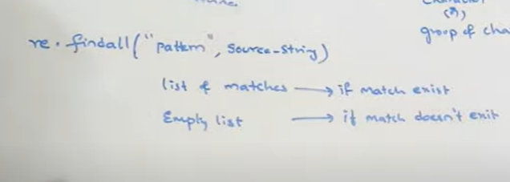

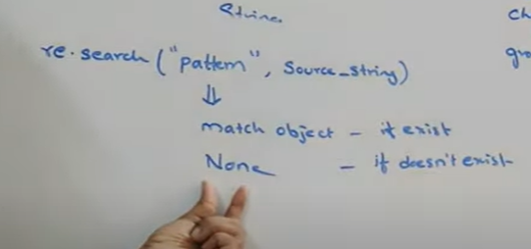

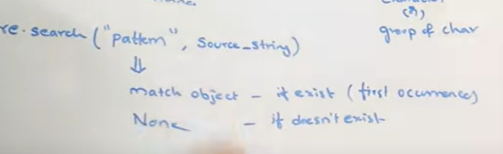

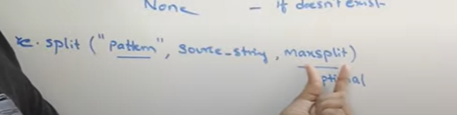

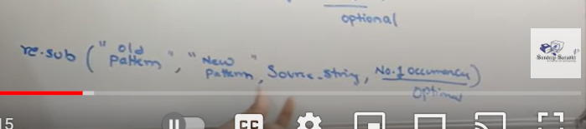

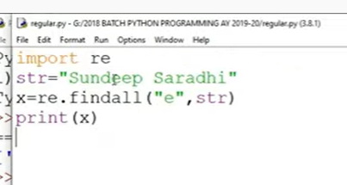

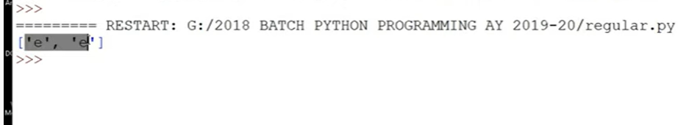

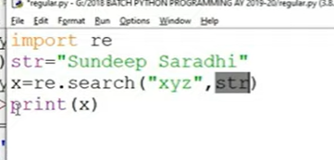

If pattern not there

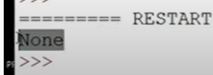

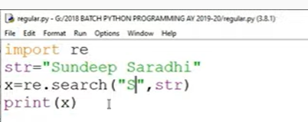

If its there itwill return match object



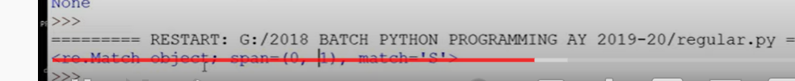

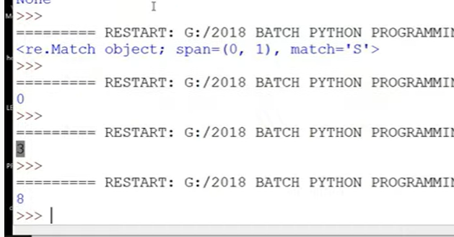

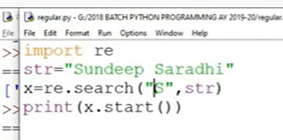

This will give index position of first match

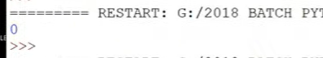

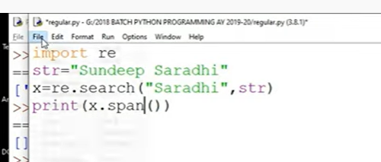

It gives range of starting to ending index

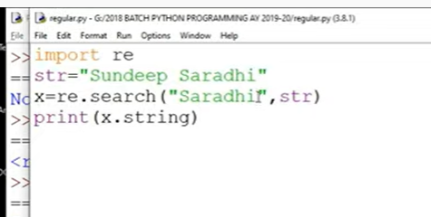

Complete string

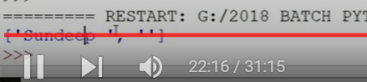

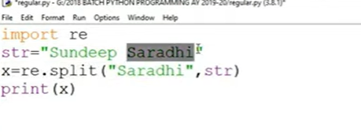

Split at space

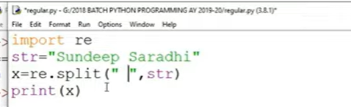

No space

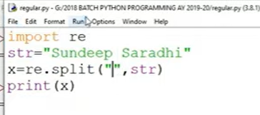



Split only at 1st space

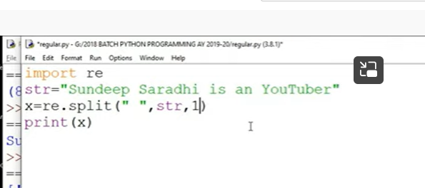

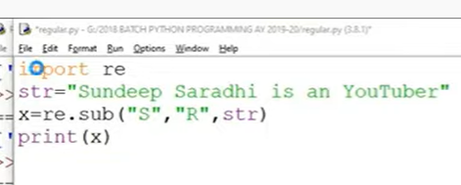

Sub is substitute

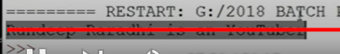

s is replaced with r

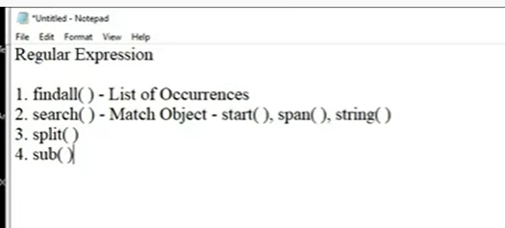

**META CHARACTERS AND SPECIAL SEQUENCES IN REGULAR EXPRESSION - PYTHON PROGRAMMING**

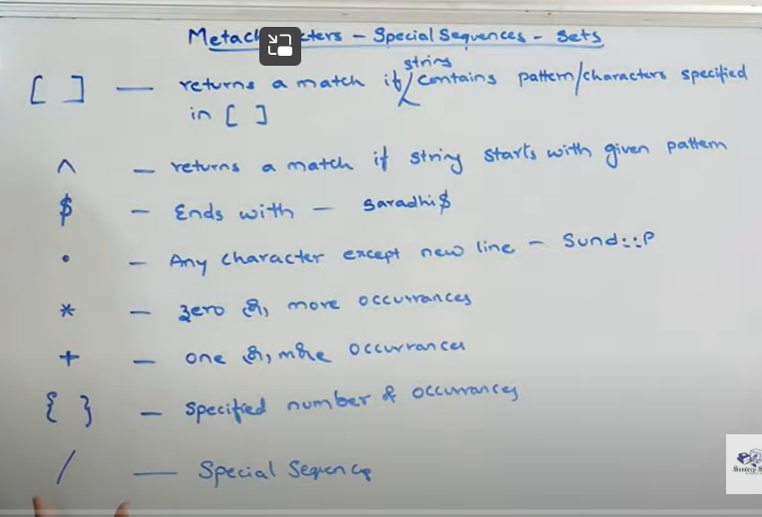

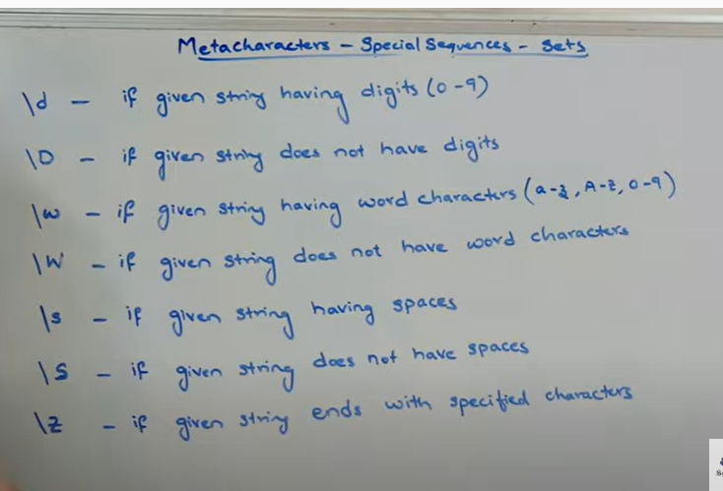

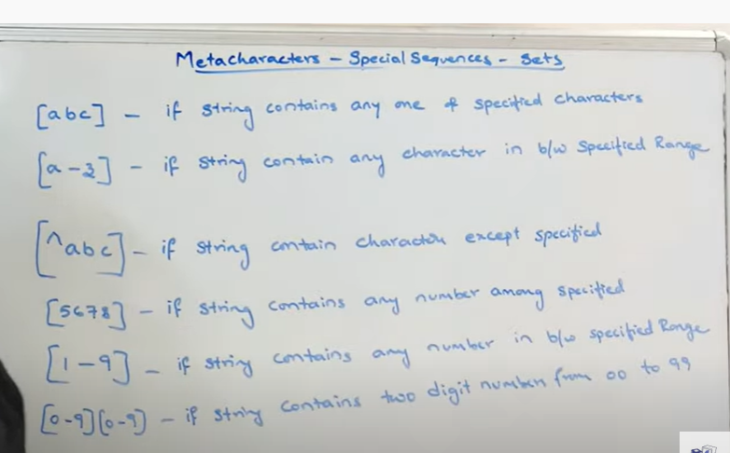

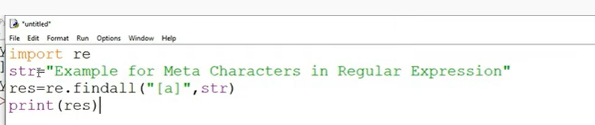

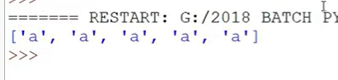

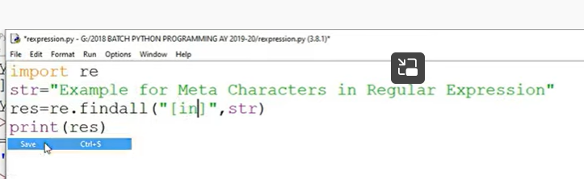

In will be taken as I separate character n separate character

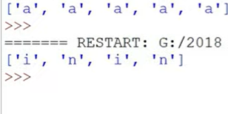

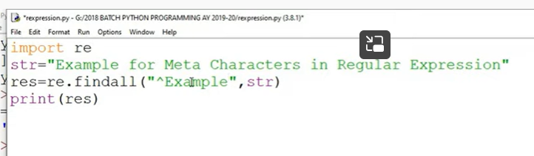

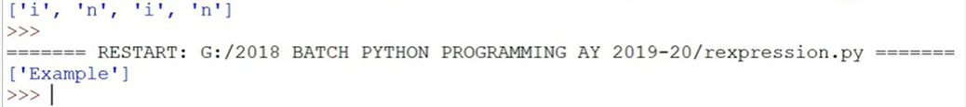

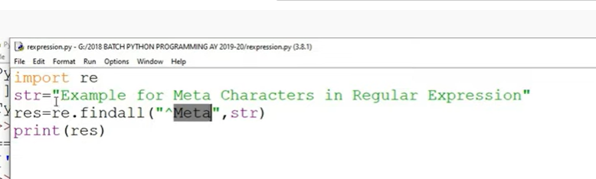

Empty list as string doest start with meta

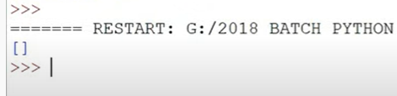

Ends with

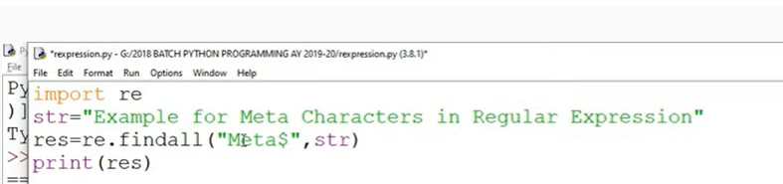

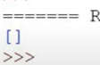

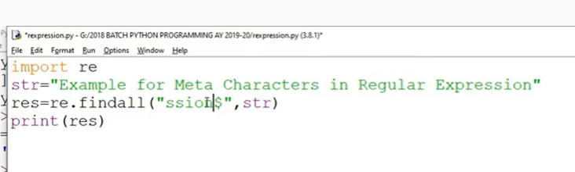

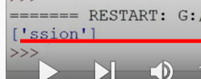

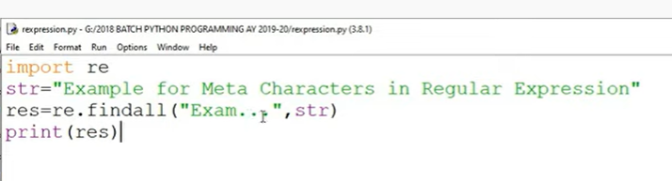

It will accept three characters



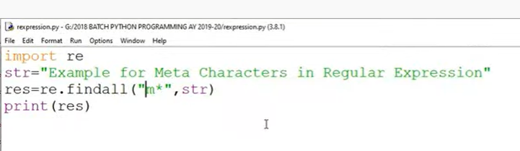

O or more occurrences

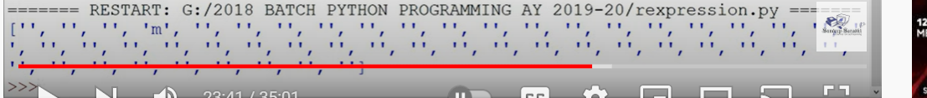

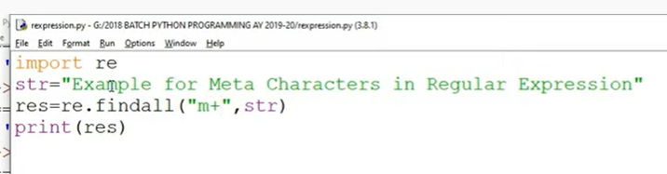

One or more

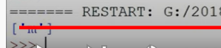

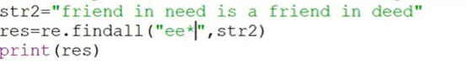

E is separate and star will apply only to last e

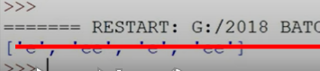

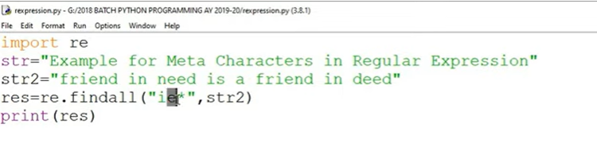

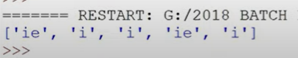

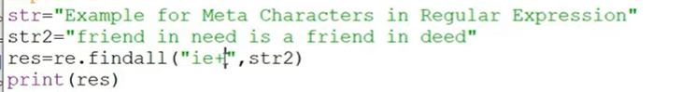

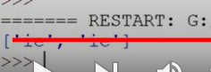

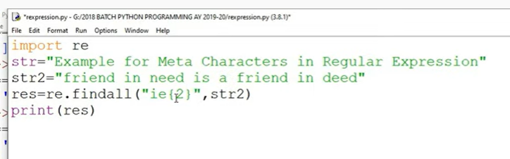

It will search for exact occurrence

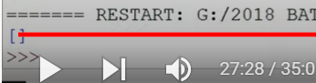

2 times of ie

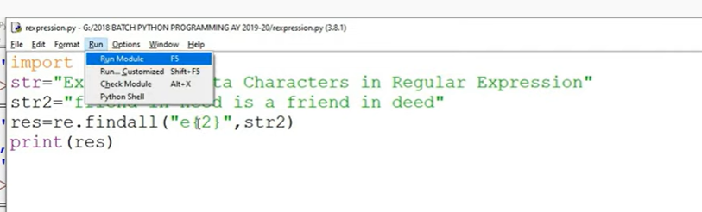



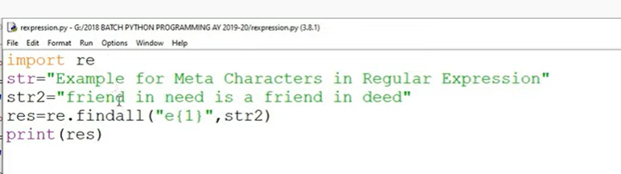

One occurrence

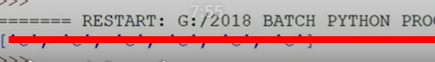

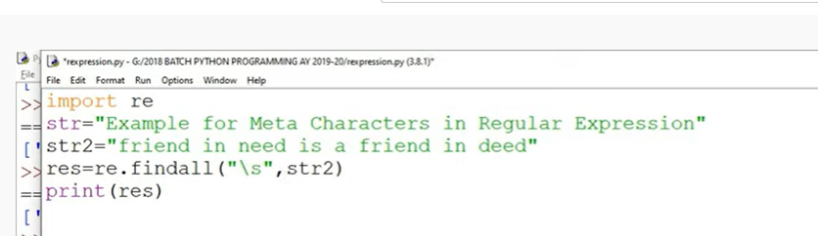

Spaces

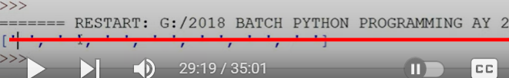

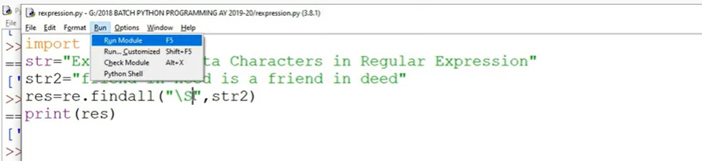

S is character without space

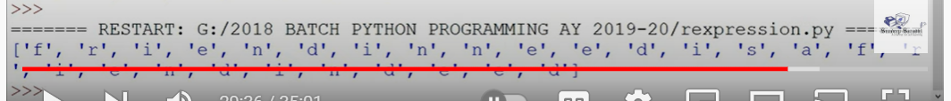

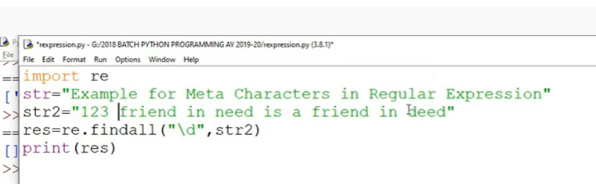

Digits

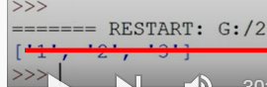

D – except digits everything

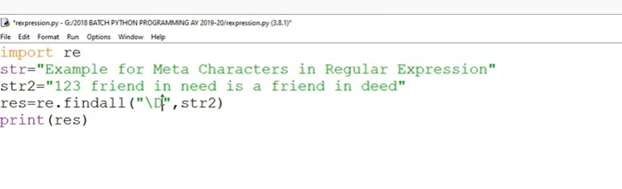

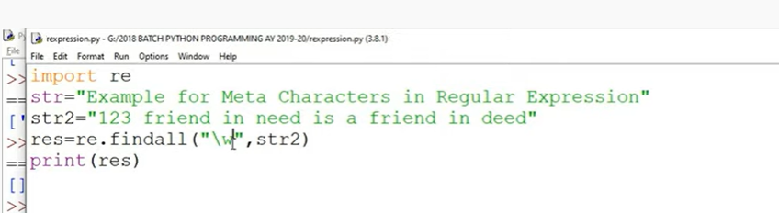

Word characters – lower, upper and numbers except space



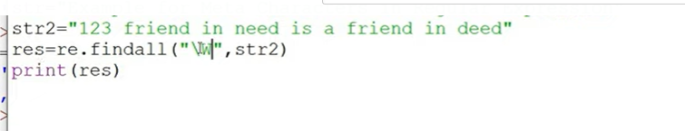

Except upper lower letters and number------ like space



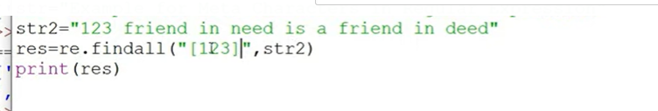

Return 1,2,3

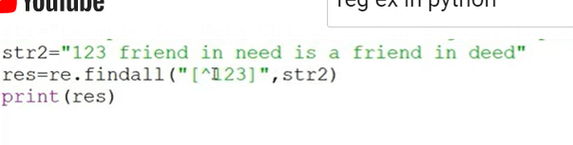

Except 1,2,3

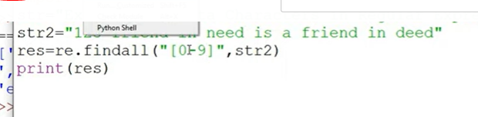

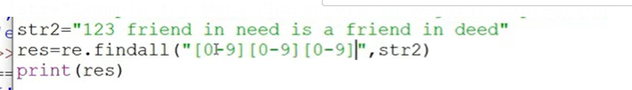

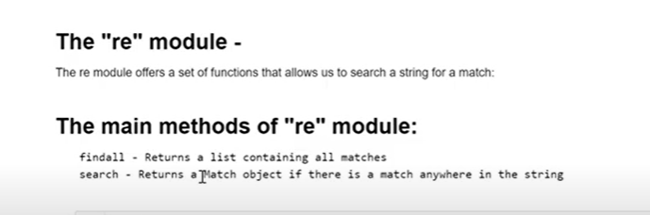

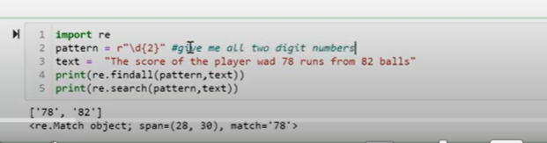

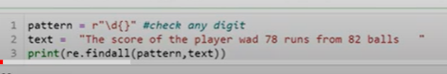

Without anything in curly braces is any digit

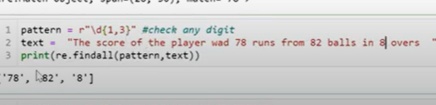

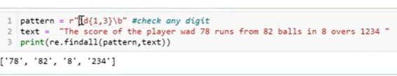

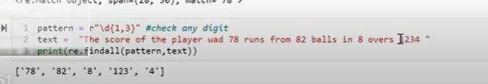

It will give splitting 4 digit number to 3 and 1

If I don’t want that number at all

Then

Boundary line

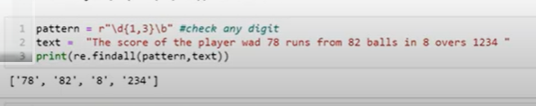

234 comes still

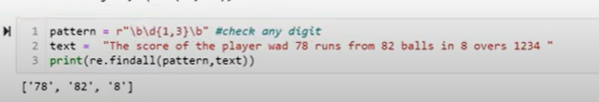

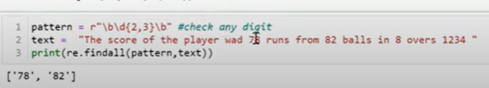

White space

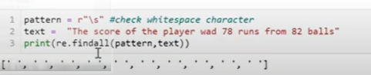

S- everything without space

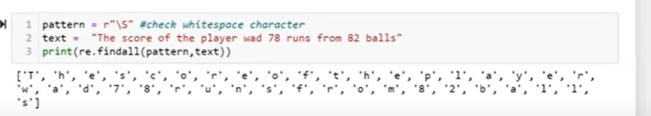

Any character .(dot)

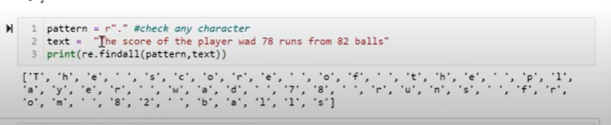

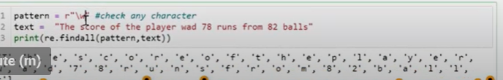

W gives everything without character

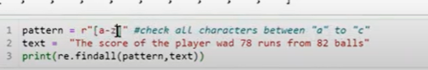

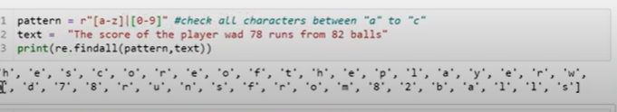

| or

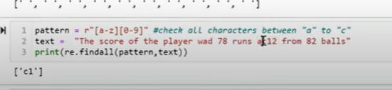

Upper

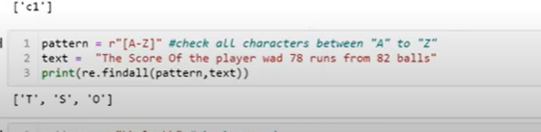

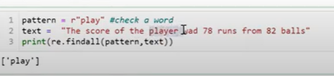

Its taking play from player

It shouldnot

Then use boundary

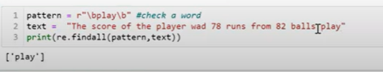

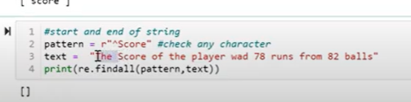

To find beginning

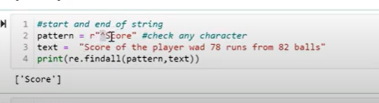

END word

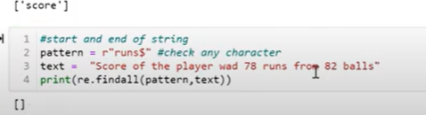

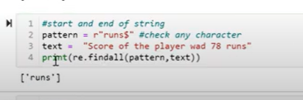

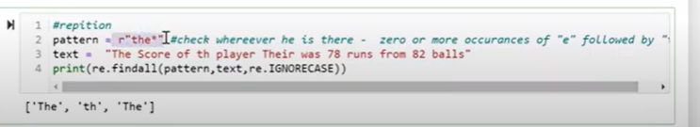

Check wherever the is there

Zero or more occurrence (*)

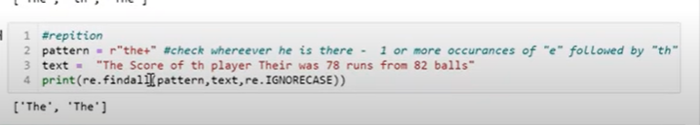

One or more occurrences(+)

